# Downloading and Installing MySQL

## 2.1 Downloading MySQL

**Step 1:**  Open Google and type **Download MySQL** and Click on **MySQL Community Downloads**

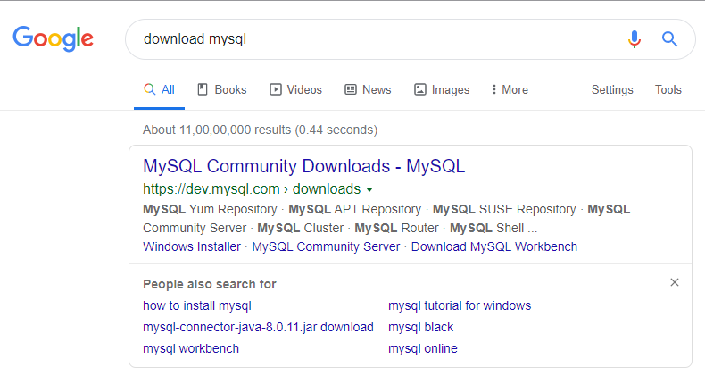

**Step 2:** Click on **MySQL Community Server**

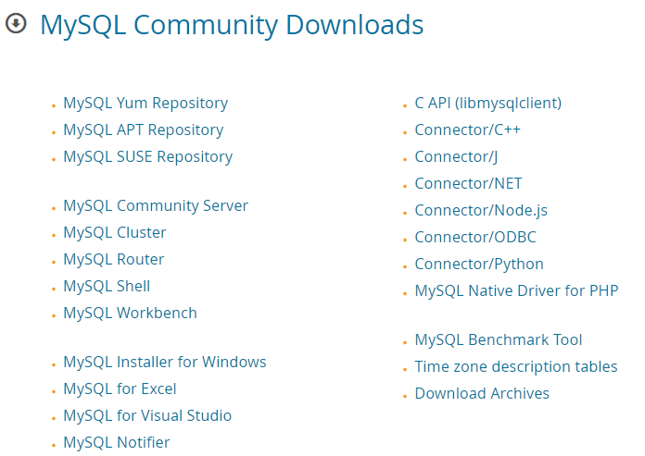

**Step 3:** Click on theMySQL installer MSI **Go to Download Page >**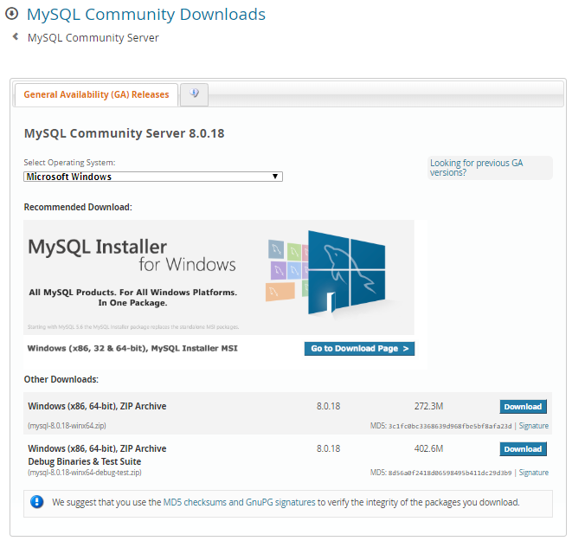

**Step 4:** Select the OS and click on **MSI Installer community**

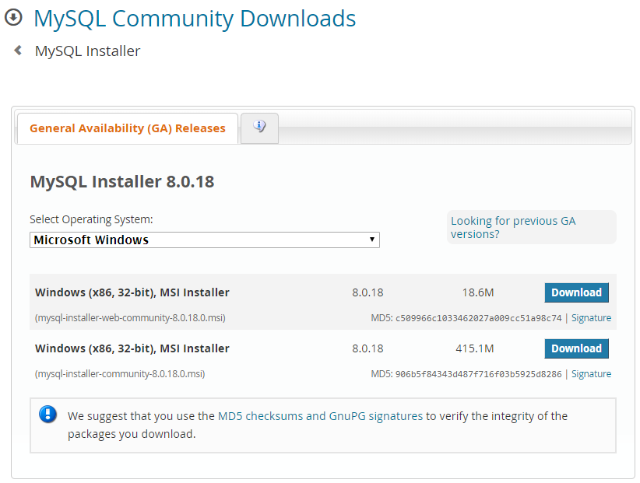

**Step 5:** Click on **start my download**

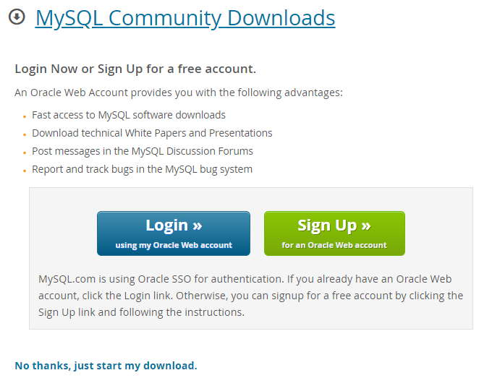

**Note:** Once the Downloading is completed, then double-click on that and install it on the local system.

## 2.2. Installation of MySQL

**Step 1:** **Double-Click** on Downloaded Application.

**Step 2:** After clicking on the application we will get a window like below

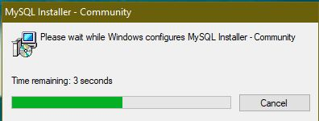

**Step 3:** Choosing the Setup type and click Next.

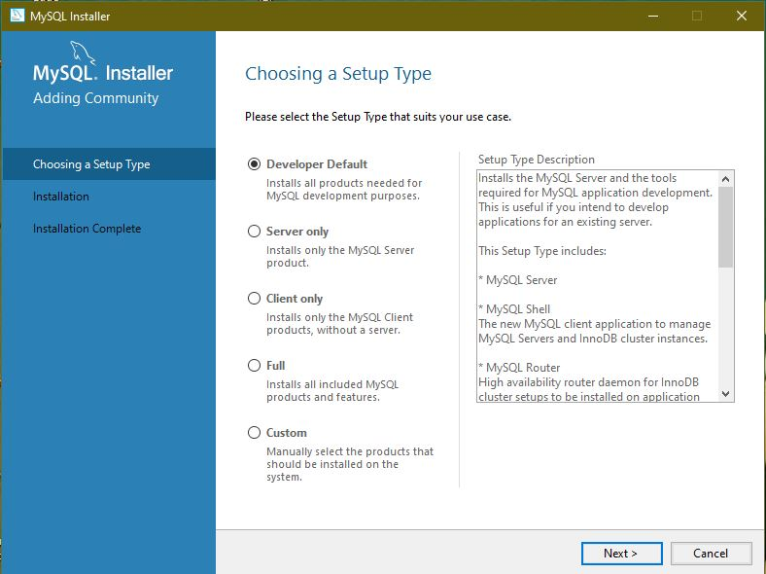

**Setup 4:** Click Next.

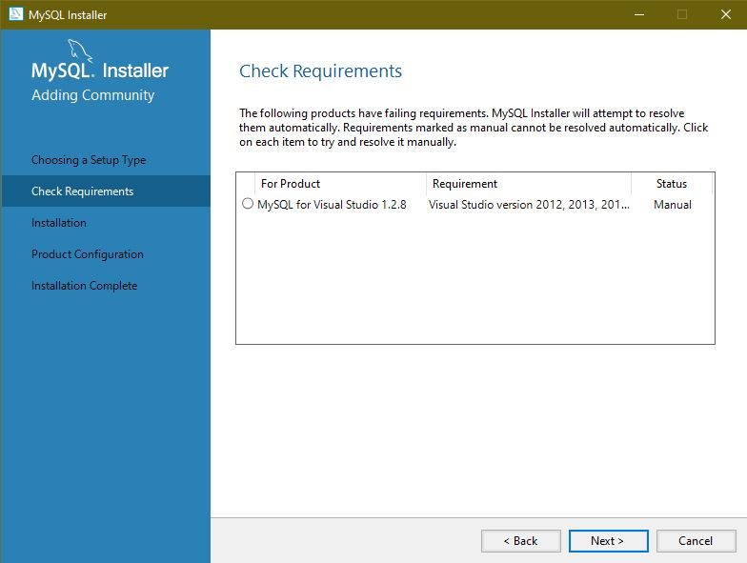

**Step 5:** Click Yes.

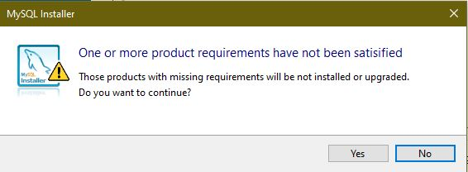

**Step 6:** Click Execute.

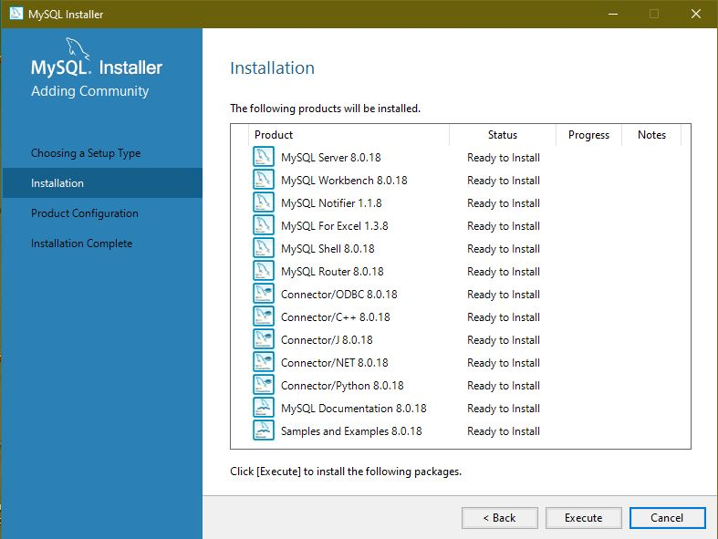

**Step 7:** After Execution, click on the Next.

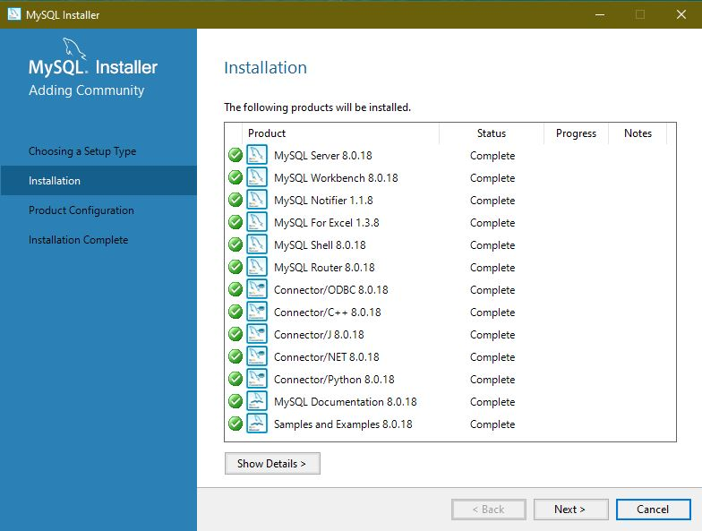

**Step 8:** Click Next.

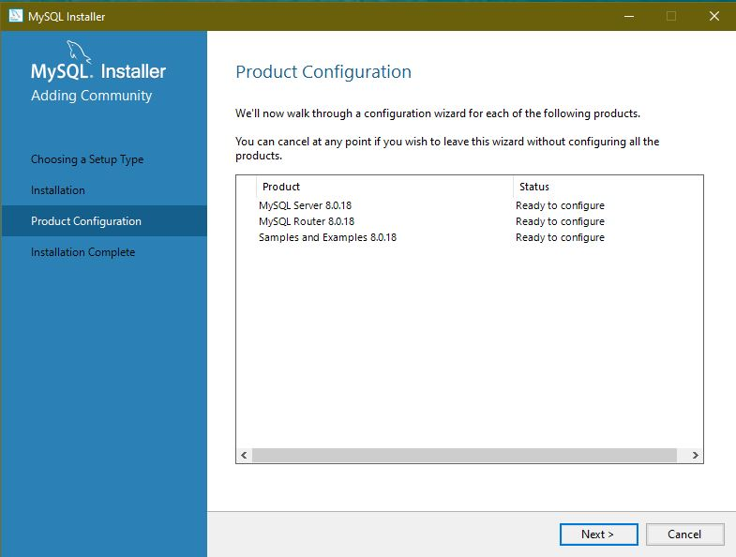

**Step 9:** Click Next.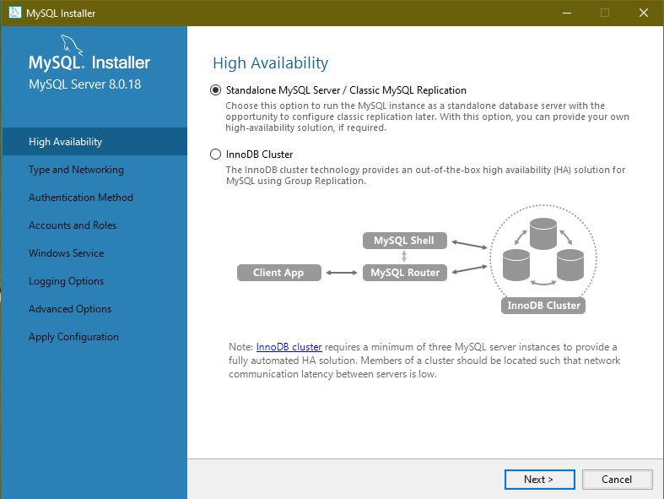

**Step 10:** Leave it as default and click Next.

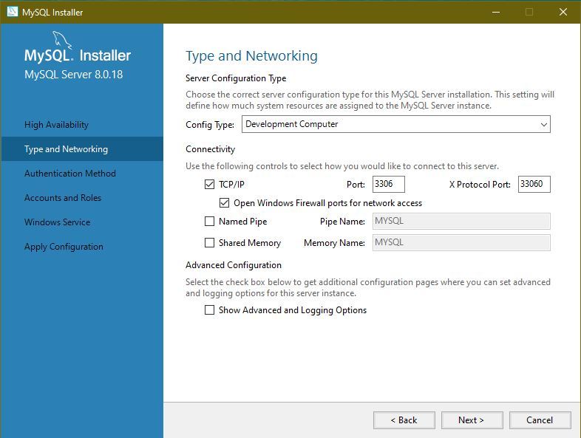

**Step 11:** Click Next

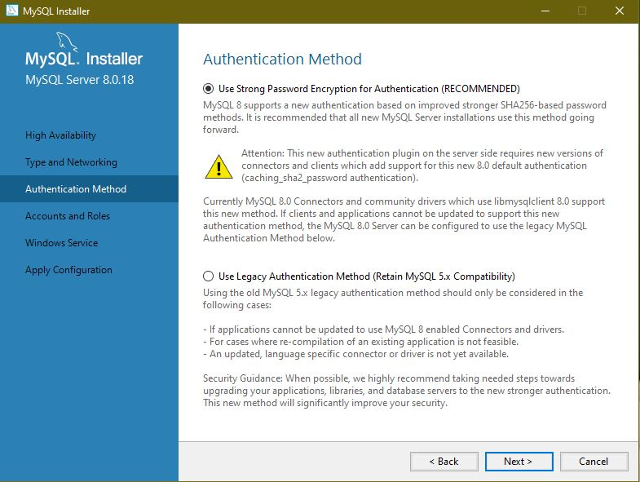

**Step 12:** Choose the root password

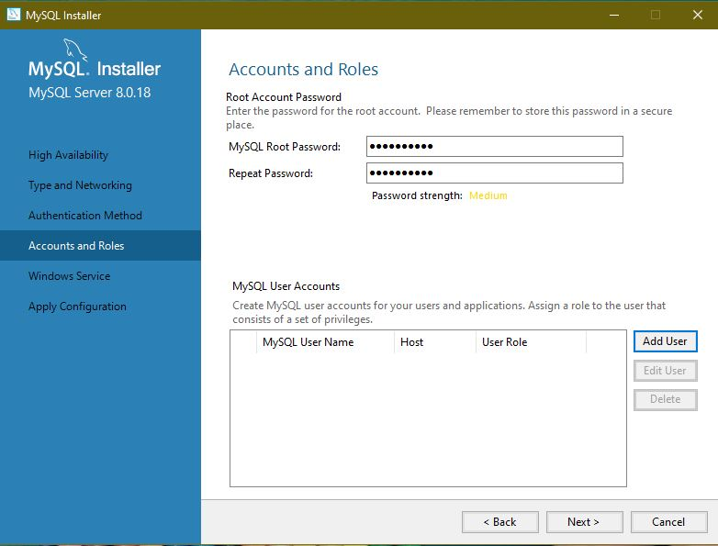

**Step 13:** Click on Add User and give the username and password.

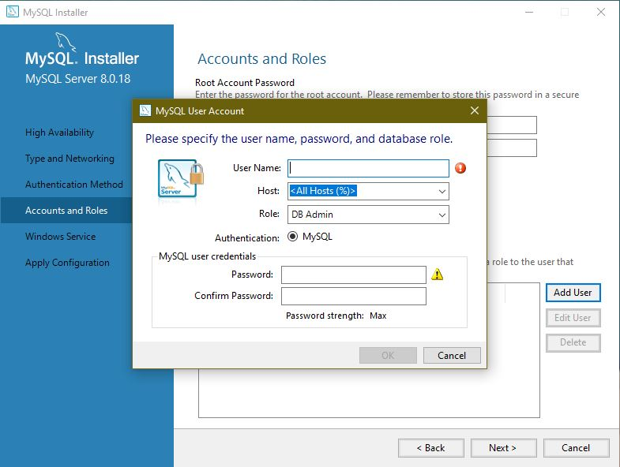

**Step 14:** After inserting the name and password click OK

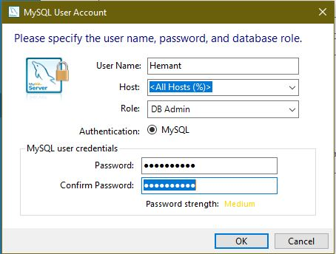

**Step 15:** After adding the user click Next

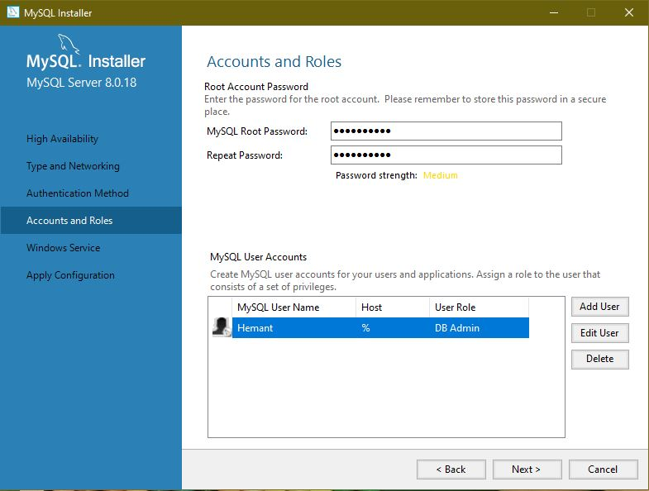

**Step 16:** Click Next

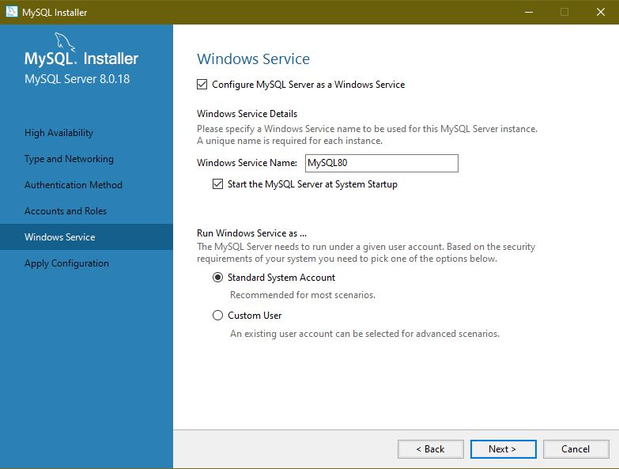

**Step 17:** Click on Execute

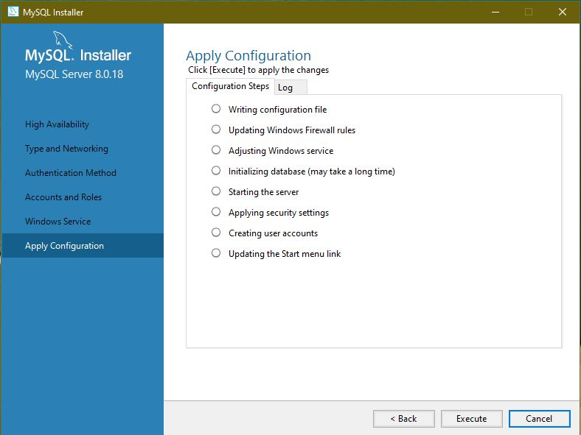

**Step 18:** After Clicking on execute,click Finish

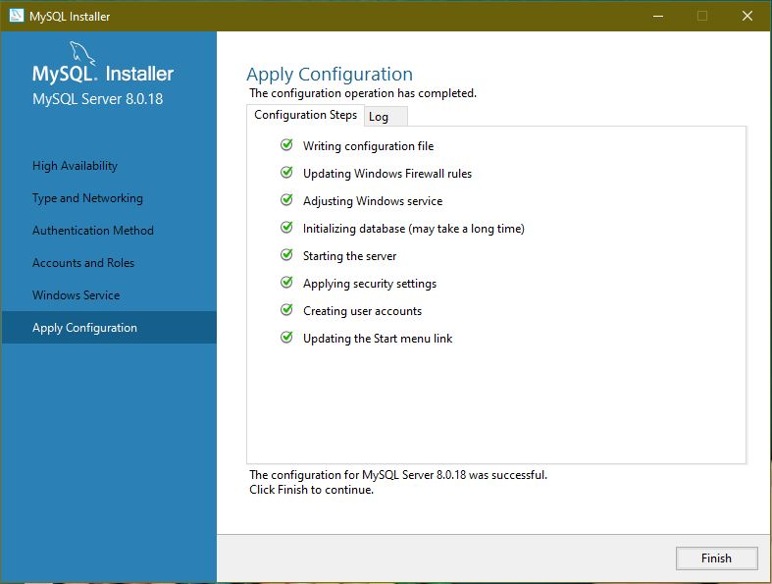

**Step 19:** Click Next

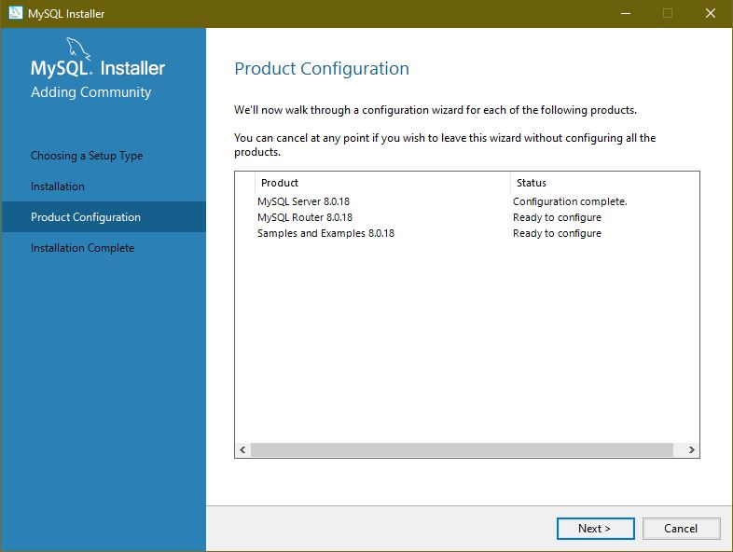

**Step 20:** Click on Finish

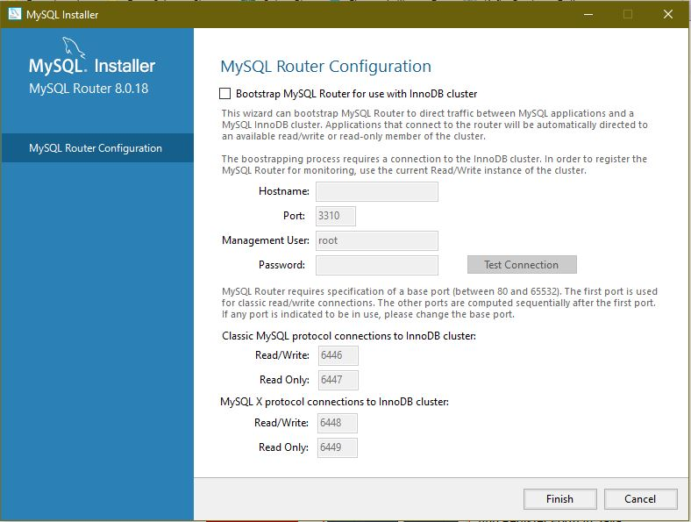

**Step 21:** Click Next.

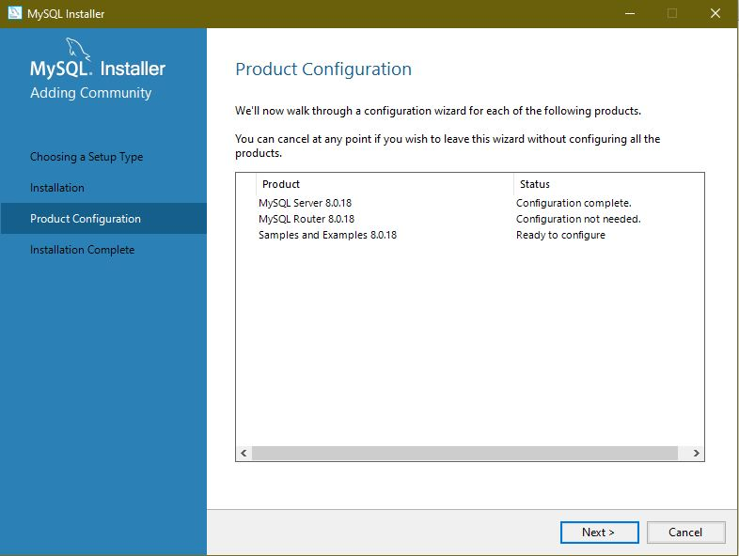

**Step 22:** Check the passwordand Click Next

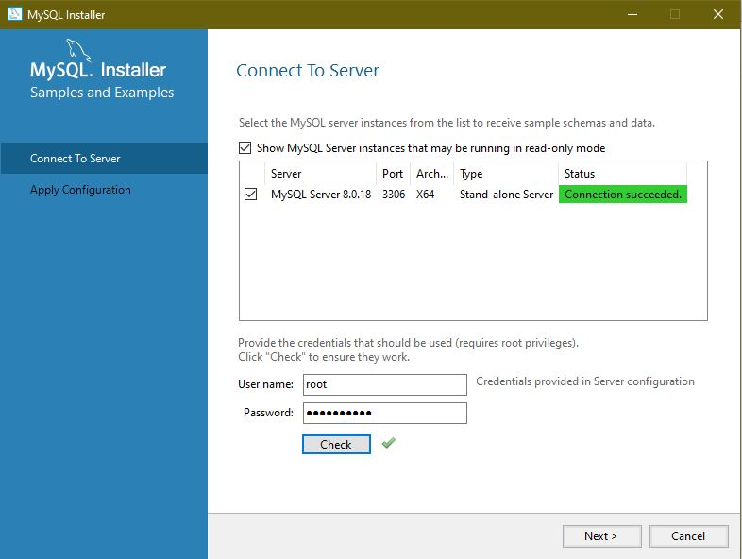

**Step 23:** Click Execute

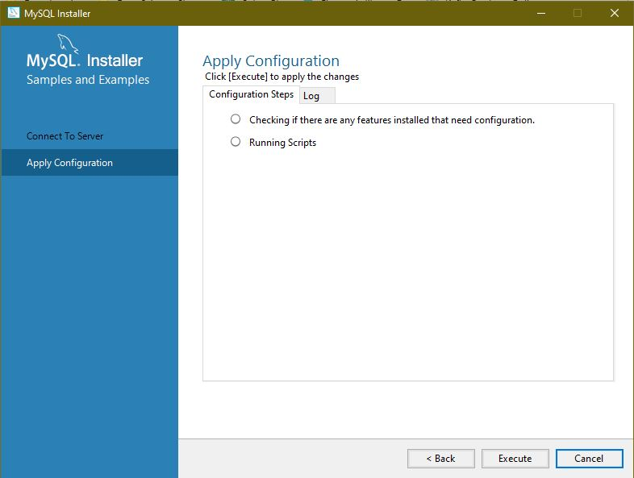

**Step 24:** After clicking on Execute

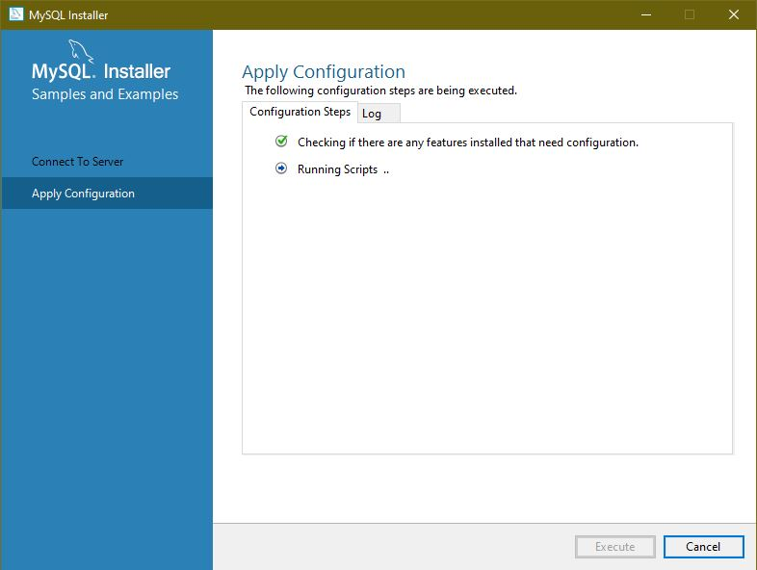

**Step 25:** Click Next

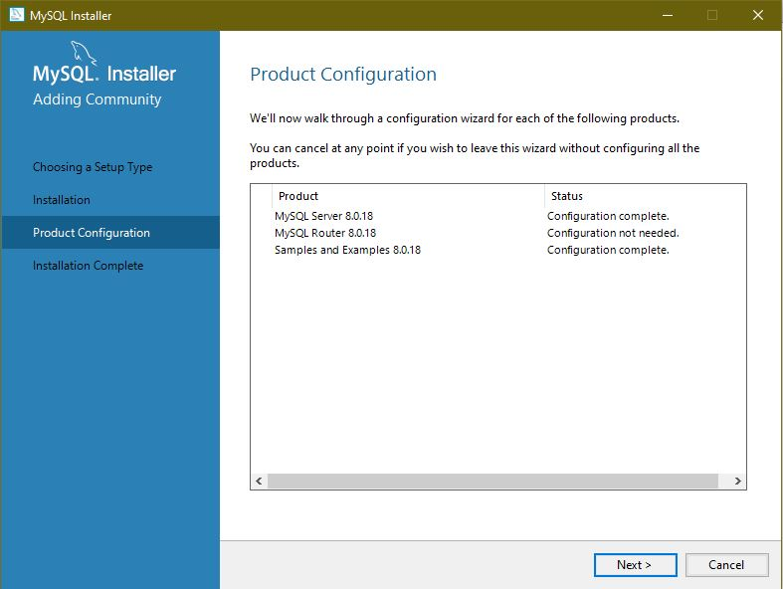

**Step 26:** Click Finish

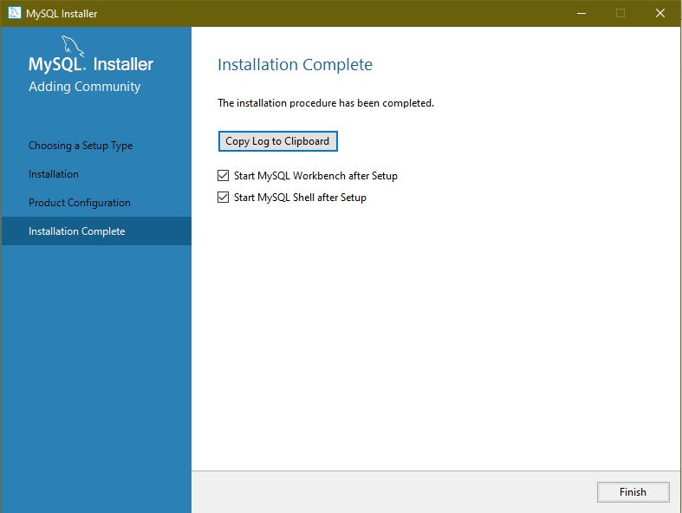

**Step 27:** After the successful installation of MySQL, two windows will open.

* MySQL Shell
* MySQL WorkBench

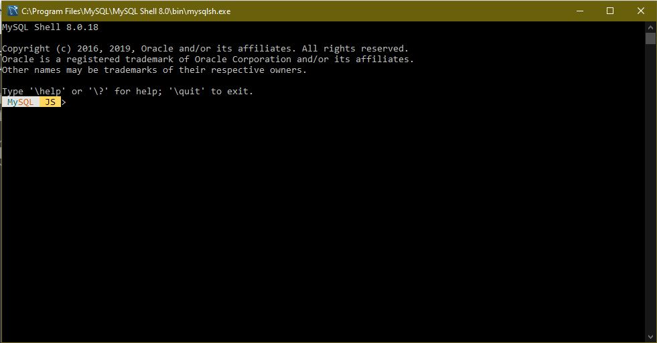

MySQL WorkBench will tell about database connectivity and other features of MySQL.

